A000-AM,S-Peru-Chimú-Figural Vessel-Monkeys-Blackware-1000 CE

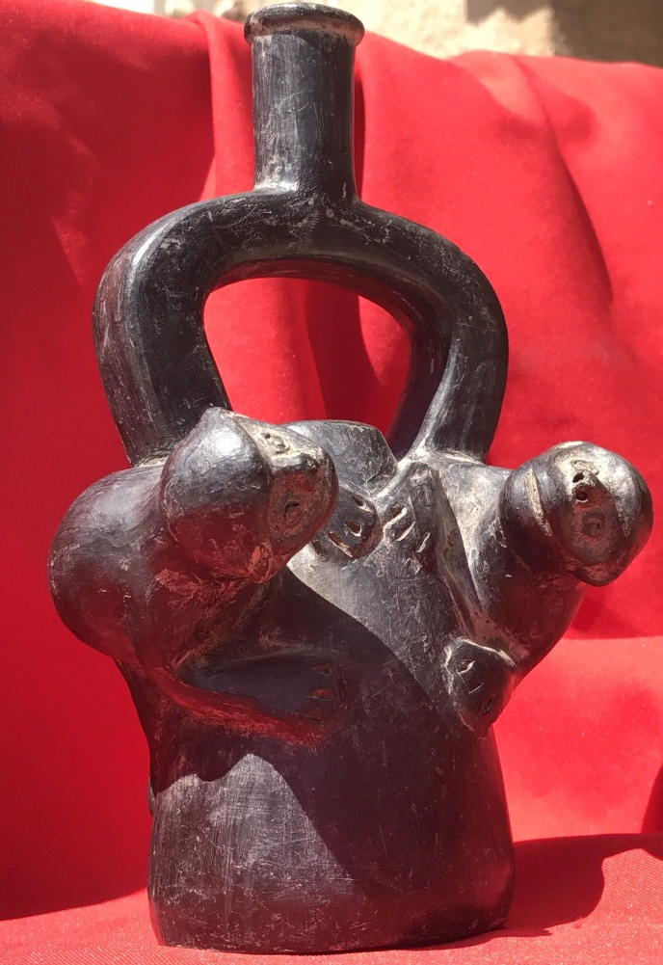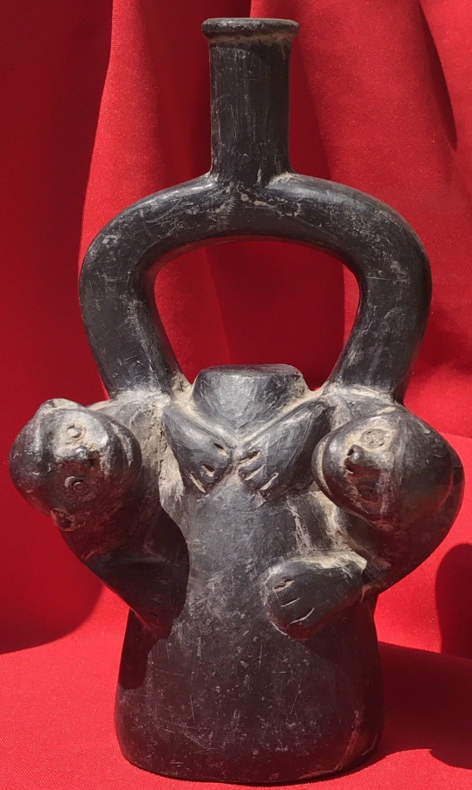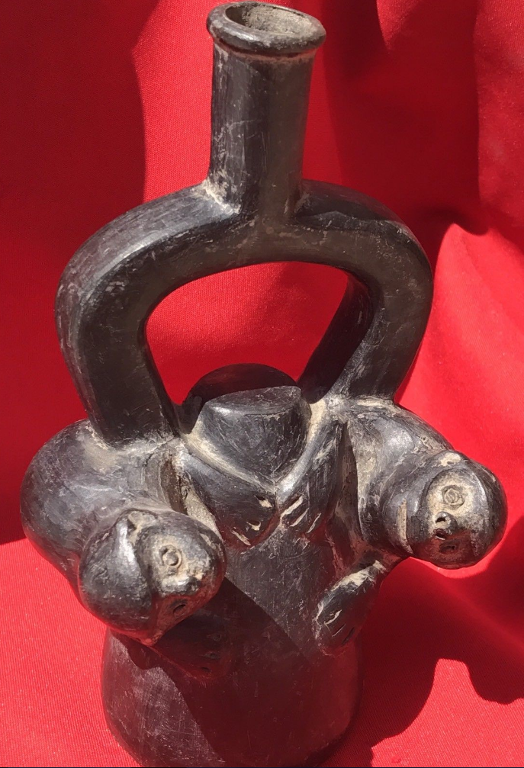

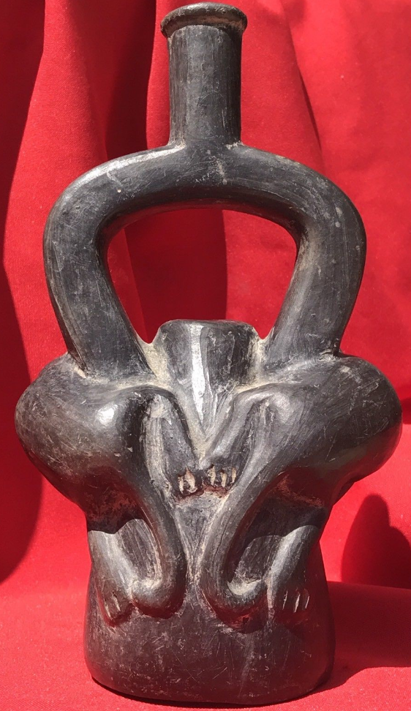

**Case no.:**

**Accession Number:**

**Formal Label:**

**Display Description: (attributed to Wiki)**

The Chimú culture was centered on [Chimor](https://en.wikipedia.org/wiki/Chimor" \o "Chimor) with the [capital city](https://en.wikipedia.org/wiki/Capital_city) of [Chan Chan](https://en.wikipedia.org/wiki/Chan_Chan), a large adobe city in the [Moche Valley](https://en.wikipedia.org/wiki/Moche_Valley) of present-day [Trujillo, Peru](https://en.wikipedia.org/wiki/Trujillo,_Peru). The culture arose about 900 CE, succeeding the [Moche culture](https://en.wikipedia.org/wiki/Moche_culture), and was later conquered by the [Inca emperor](https://en.wikipedia.org/wiki/Inca_Empire) [Topa Inca Yupanqui](https://en.wikipedia.org/wiki/Topa_Inca_Yupanqui" \o "Topa Inca Yupanqui) around 1470, fifty years before the arrival of the Spanish in the region.[[2]](https://en.wikipedia.org/wiki/Chim%C3%BA_culture#cite_note-2)

The Chimú resided on a strip of desert on the northern coast of [Peru](https://en.wikipedia.org/wiki/Peru). The rivers in the region carved a series of fertile valley plains, which were very flat and well-suited to irrigation. Agriculture and fishing were both very important to the Chimú economy.[[3]](https://en.wikipedia.org/wiki/Chim%C3%BA_culture#cite_note-Howland-3)

Worshipping the [moon](https://en.wikipedia.org/wiki/Moon), the Chimú, unlike the Inka, considered it more powerful than the [sun](https://en.wikipedia.org/wiki/Solar_deity). Offerings played an important role in religious rites. A common object for offerings, as well as one used by artisans, was the shell of the [Spondylus](https://en.wikipedia.org/wiki/Spondylus" \o "Spondylus) shellfish, which resides only in the warm coastal waters off present-day [Ecuador](https://en.wikipedia.org/wiki/Ecuador). Associated with the sea, rainfall, and fertility, [Spondylus](https://en.wikipedia.org/wiki/Spondylus" \o "Spondylus) shells were highly valued and traded by the Chimú people, and the exchange of the shells played a significant economic and political role in the empire.[[4]](https://en.wikipedia.org/wiki/Chim%C3%BA_culture#cite_note-4)

The Chimú people are best known for their distinctive monochromatic pottery and fine metal working of [copper](https://en.wikipedia.org/wiki/Copper), [gold](https://en.wikipedia.org/wiki/Gold), [silver](https://en.wikipedia.org/wiki/Silver), [bronze](https://en.wikipedia.org/wiki/Bronze), and [tumbaga](https://en.wikipedia.org/wiki/Tumbaga" \o "Tumbaga) (copper and gold). The pottery is often in the shape of a creature or has a human figure sitting or standing on a [cuboid](https://en.wikipedia.org/wiki/Cuboid) bottle. The shiny black finish of most Chimú pottery was achieved by firing the pottery at high temperatures in a closed [kiln](https://en.wikipedia.org/wiki/Kiln), which prevented [oxygen](https://en.wikipedia.org/wiki/Oxygen) from reacting with the [clay](https://en.wikipedia.org/wiki/Clay).

**LC Classification:**

**Date or Time Horizon:**

**Geographical Area:**

**Map:**

**GPS coordinates:**

**Cultural Affiliation:**

**Medium:** firing the pottery at high temperatures in a closed kiln, which prevented oxygen from reacting with the clay produced a black finish.

**Dimensions:**

H 20 cm 8 in

**Weight:**

**Condition: original**

**Provenance:** Garcia Fernandez collected this ceramic while living in Peru 1950-1980.

**Discussion:**

**References:**